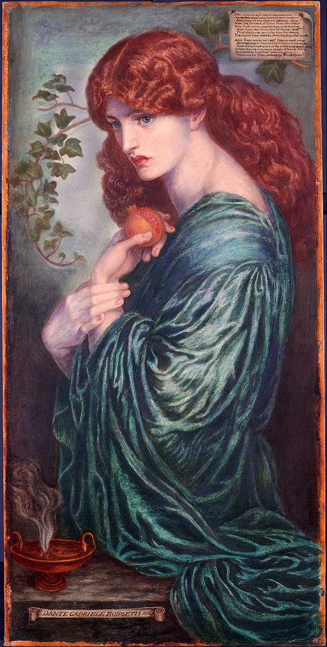
Let’s Rename Pluto
Craig Chalquist
Chalquist.com
April 2020 (a few days after a Pluto retrograde)
It should have been named Proserpina, goddess of the underworld and death-to-life renewal. The ancient Greeks knew her as Persephone.
Perhaps it will seem strange that a terrapsychologist—someone who studies how the things of the world, natural or otherwise, show up as presences inside us—occasionally stares up at the sky. However, the split between heavens and Earth is relatively recent, historically speaking, and by no means universal. Nature-celebrating cultures appreciatively watch the cycling stars as well as the soils, winds, and seas. Perhaps we should too.
I will root my argument in five observations familiar to some of us—including broad-minded scientists*—through lived encounters, but seldom if ever acknowledged by the materialist ideology of scientism:
- The relationship between planetary and earthly events are synchronistic rather than causal (C. G. Jung), which places them in the realm of storytelling and meaning-making. (To say it academically, we are working here with hermeneutics, not empirics; qualities, not quantities.)
- Meanings of personal names often link synchronistically to events of discovery.
- What we give mythological names to tend to exhibit mythic qualities (terrapsychology): the reverse of psychological projection theory, which assumes a human influence over everything we perceive.
- Myths don’t stay in myth books: they roam at will like blobs of collective psyche in search of retellings, even influencing the means by which we employ them (see my book Myths Among Us).
- The planet names in both Western astrology and astronomy show a masculinist bias in need of correction.
Let me begin, briefly, with what brought all this to the surface for me.
* Kripal, J. (2919). The Flip: Epiphanies of Mind and the Future of Knowledge.
Beginning: Proserpina Approaches
To oversimplify somewhat with an anecdote:
Four years ago, Pluto began “his” approach to my natal South Node, which lies just beneath my Descendant in Capricorn. North and South Lunar Nodes are where the traveling Moon crosses the plane of the ecliptic, the path along which the other planets move as seen from Earth. (In astrology, “planets” include Sun and Moon.) The South Node symbolizes where we come from, basic security issues, lessons from the past, traits we hang on to. Where we start out from. The North Node indicates where we need to go. In Capricorn, the South Node wears themes of overwork, overachievement, and reluctance to depend on others. In House 6, these also show up in work and health.
The Descendant involves close relationships. In Capricorn, this can mean partners who are self-contained, serious, and ambitious. It is also where the Sun sets on its daily journey into the underworld.
Pluto intensifies what it touches. It brings the dramatic and transformative motif of death-and-rebirth. Pluto can also signal the entry of shadowy underworld figures onto life’s stage.
As Pluto reached my South Node and then my Descendant, with Saturn following close by, upheavals multiplied, beginning with my exiting one life myth (= overarching story) and walking into another. This altered several long-term goals. The workplace I had entered with such high hopes turned out to be riddled with conflicts of interest, ego, and power, prompting me to leave in deep disillusionment. My adoptive and birth fathers died within a year of each other. A close friend was diagnosed with thyroid cancer. A relationship ended. My mother’s savings were stolen by a long-trusted aide.
Throughout these disruptions, I dreamed continually not of Pluto, but of Persephone: beckoning me, embracing me, pacing outside my dad’s home months before he died. After this series of inner and outer deaths I understood why Odysseus, who had entered the underworld in dark foreboding, had referred to her as the “iron queen.” Only after most of the turbulence had passed did I think to connect Persephone to the astrological parallels of that time.
These connections are relevant to my interest because of their “meaningful coincidence” quality. I am not aware of convincing evidence that Pluto or any other planet directly influences life down here. Celestial symbols are not causes.
All this made me curious about why this planet of mythic intensification was named Pluto (“wealth”) and not Proserpina.
Underworld Motifs in Pluto’s Discovery
Percival (“pierce”) Lowell (“young wolf”) was no stranger to wealth. Born in the spring into a rich Bostonian family, he trained in science and mathematics at Harvard, ran a profitable cotton mill, and served in various political appointments, including foreign secretary. He purchased his own astronomical instruments and used his money to found the observatory named after him.
Lowell was of the sort who sometimes enjoyed serendipitous accomplishments through mythological mistake-making. He was sure about the fictional canals on Mars, for instance, and the spoked shape he saw on Venus was a glassy reflection of his own inquisitive eye. Then he convinced himself that an undiscovered Planet X was warping the orbits of Uranus and Neptune. This proved unfounded, but it did point him in the right stellar direction, a fact later put down to coincidence. Unknown to him, he had captured very faint images of well-hidden Pluto twice in 1915. The underworld claimed him the following year.
Pluto hid through a decade of financial battling between reclusive real estate speculator Constance Savage Lowell and the observatory named after her departed husband. Then 22-year-old Clyde (“river” in Scotland) Tombaugh (“by the creek”) emerged from an Illinois farm bearing impressive astronomical sketches and a desire to find Planet X. To do this he used a blink comparator: a device for showing image displacements between pairs of photographs. On February 18th, 1930, he noticed one such moving image in the constellation Gemini. The discovery of the new dwarf planet was announced on March 13th, Percival Lowell’s birthday and the day of William Herschel’s discovery of Uranus.
Despite her fight to defund the observatory, Constance Lowell took it upon herself to pitch three names for the new heavenly body: Zeus, Percival, and Constance.
Venetia (“good hound” or “fair, white”) Burney (“island of the brook”), a schoolgirl in Oxford, offered the name Pluto for the cold, dark, distant world. “Pluto” kept to the Roman deity naming tradition, and first two letters reminded the official choosers of Lowell’s initials. They announced their decision on May 1st, 1930. Astronomer Carl Lampland made the first spoken announcement, in Ashurst Hall at Northern Arizona U (current name), but the acoustics were bad and few heard his quiet voice.
In the first edition of Archai: The Journal of Archetypal Cosmology, Richard Tarnas, author of Cosmos and Psyche, had this to say about such synchronistic timing:
With respect to Pluto’s discovery, the synchronistic phenomena in the decades immediately surrounding 1930, and more generally in the twentieth century, include the splitting of the atom and the unleashing of nuclear power; the titanic technological empowerment of modern industrial civilization and military force; the rise of fascism and other mass movements; the widespread cultural influence of evolutionary theory and psychoanalysis with their focus on the biological instincts; increased sexual and erotic expression in social mores and the arts; intensified activity and public awareness of the criminal underworld; and a tangible intensification of instinctually driven mass violence and catastrophic historical developments, evident in the world wars, the holocaust, and the threat of nuclear annihilation and ecological devastation. Here also can be mentioned the intensified politicization and power struggles characteristic of twentieth-century life, the development of powerful forms of depth-psychological transformation and catharsis, and the scientific recognition of the entire cosmos as a vast evolutionary phenomenon from the primordial fireball to the still-evolving present.
Why “Proserpina”?
My anecdotal encounters aside, can we detect the presence of the underworld goddess in any of these events?
At first, “Pluto” seems the right name, thematically, for the cold world so far from our own. Surface temperature: an average of -229 Celsius (-380 Fahrenheit). From that surface, our sun is but a luminous speck four billion miles away—but on average, because Pluto has the most elliptical (and tilted) orbit of any planet, at one point passing inside the orbit of Neptune. The path of Proserpina shares a similar looping: half the year in the underworld, half above it.
The story goes that one day the young woman was out gathering flowers near a lake when Pluto emerged from a volcano. Struck by a love arrow ordered by Venus and shot by her son Cupid, the chariot-riding god seized her and dragged her under.
Her mother Ceres searched for but could not find her, just a belt floating on a lake of tears. Her pleading with the other gods struck a new balance: Proserpina would spend the months of cold in the underworld and those of flowering plants in the upper. From that point onward, she ruled the underground realm of death with Pluto. In many tales, she is the active partner who meets those who arrive.
Looking again at the list of plutonic synchronicities assembled by Tarnas (above) from a Proserpina perspective, many seem to involve violence against the innocent and the undeserving, including destruction of the natural world. We might add that in 1930, the Great Plains of the U.S. went into the kind of drought caused by grieving Ceres, migrating everywhere to look for lost Proserpina, her sorrowing earth mother’s wandering footsteps imprinting deserts on the land. This agricultural catastrophe in turn fed the Great Depression. Crises rampant throughout the 1930s culminated in World War II.
Tarnas also points out that the astrological qualities of Pluto echo those of Dionysus, associated by the ancient Greeks with Hades:
…The planet Pluto is also linked to Nietzsche’s Dionysian principle and the will to power and to Schopenhauer’s blind striving universal will—all these embodying the powerful forces of nature and emerging from nature’s chthonic depths, within and without, the intense, fiery elemental underworld.
Will would not be a quality necessarily associated, at least in myth, with quiet Pluto, who tended to hide away and let things run (down) themselves. Perhaps Constance Lowell expressed a bit of blind will while pretending to be sightless in order to get her way. Be that as it may, the name of willful, assertive Proserpina points back to the Latin proserpere: “to emerge,” which she does every year. Also, she harks back to the Roman goddess Libera (Proserpina/Libera: PL), wife of Liber, the Roman Dionysus, with whom she shared wild libidinal festivals. She was his feminine half, her free spirit fusing and exploding in worldwide movements of liberation.
The astrological glyph for Pluto unintentionally recalls a blossom seen from the side. Proserpina had picked one shortly before landing in the underworld. The lake near where she had dallied, the water in the names of the various astronomers, and the rivers in the underworld are thematically one. The time of discovery and announcement was the spring season, when Proserpina announces herself by emerging into the light.
Proserpina’s Say
Perhaps her abduction initially seemed like a kind of demotion. Certainly it seemed that way for Pluto, which in 2006 was reduced by the International Astronomical Union from planet to dwarf planet. At that time Pluto stood retrograde in Sagittarius, a sign of reassessment and far-reaching decisions. In a chart drawn at the time and place of the meeting, Pluto occupied House 1: how you appear to others.
To be a planet, astronomically, you must clear the space around your orbit and stay in your lane. Pluto did neither. Also, Eris, a dwarf planet discovered in 2005, was found to hold more mass than Pluto. The resulting controversy recalled the Eris of myth as a deity of discord. It was as though Pluto as world was no longer needed in the heavens, what with the industrially driven conversion of so much of Earth’s surface into an ecologically barren underworld.
Most astrologers ignored this demotion. Comparisons between life events and Pluto’s movements convinced them that the chronological parallels assembled since 1930 were valid.
Furthermore, an asteroid had been promoted: Ceres, mother of Proserpina, now a dwarf planet.
This may be the final scientific say on Pluto’s status as planet, but it will not be Proserpina’s. I expect her to keep surfacing, synchronistically and in other ways. Perhaps the underlying issue is collective acceptance of transformation, death, and rebirth. When our consciousness catches up with what she signals to us, new openings in it will allow to her reappear.
Incidentally, Pluto is orbited by the moon Charon, named after the ferryman of Hades. If Pluto is ever renamed Proserpina, perhaps Charon should be renamed Pluto? Symbolically speaking, is the dark northern polar cap the invisibility hat of Hades? The science team of the New Horizons probe that passed these worlds in 2015 informally named the cap Mordor.
Perhaps the most evocative discovery made by this probe arrived in a high-resolution image: a thousand kilometers of nitrogen ice cast in the shape of a giant heart renewed invisibly from below.
